SUSTAINABILITY
MANAGEMENT SYSTEM

Contents

1. MANAGEMENT SYSTEM 2
2. LEGAL COMPLIANCE 5
3. STAKEHOLDERS AND COMMUNICATION 5
4. ACCESSIBILITY 7
5. PURCHASING 7
6. CULTURAL SUSTAINABILITY POLICY 8
7. ENERGY AND ENVIRONMENT 9
8. WATER MANAGEMENT AND WASTEWATER 10
9. FOOD WASTE AND SOLID WASTE ………………………………………………………………………11

1. Management System

This document forms the basic framework of a Sustainability Management System (SMS) that can be adapted and developed to cover all management processes of our hotel and sets out its policies. This document has been prepared for the management and staff of the hotel. Our system has been developed to suit the size and scope of our hotel.

The basis of our management system is based on risk analysis. Risk analysis is carried out under the headings of environment, natural disasters, society, culture, economy, quality, human rights, health, and security. New headings can be added if necessary.

After the risks are analyzed, we also have a crisis management policy and system that determines what to do in the event of the risks occurring. The annex of this document includes how to conduct risk analysis and crisis management.

Risk analysis is performed using the method specified in A1-c2.

SYS includes the implementation of certain policies by all employees on quality, economy, management, environment, culture, human rights, health and safety, the determination of targets and the continuous improvement of business management processes by monitoring whether the targets are achieved.

If the determined targets are achieved, new targets are determined. If not achieved, our targets, policies and practices are reviewed. In this way, we strive to ensure continuous improvement.

The targets related to our hotel's management system and the performance indicators that monitor compliance with the targets are included in the annex of this document.

Our hotel's objectives and performance indicators are located in A1-c1.

Our hotel undertakes to fulfill the first stage obligations of the Turkey Sustainable Tourism Program regarding sustainability and to continuously improve the sustainable management system in order to increase sustainability performance.

Our management system is constantly reviewed due to the status of the sector, environmental, social, technological, economic and cultural risks, changes and updates originating from legislation, and if necessary, the system and policies are updated.

The steps mentioned above can be summarized as the Plan-Do-Check-Take Action (PDCA) approach (Figure 1).
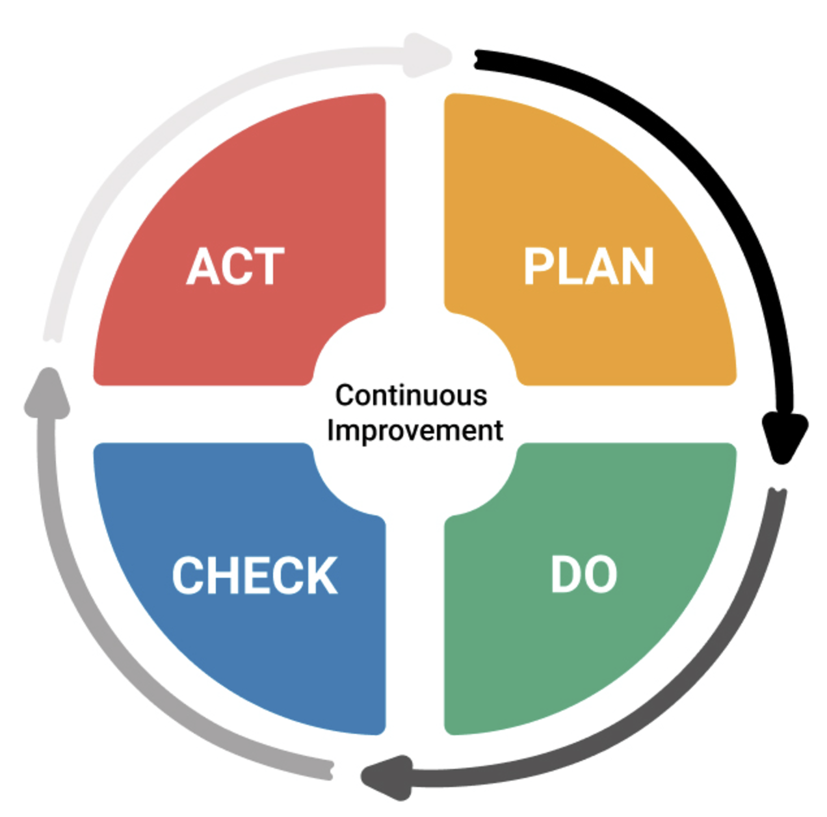
Figure 1.Continuous Improvement

Plan: Our hotel attaches importance to the environment, society, culture, national economy and management system and sets goals. It plans the roadmap and actions to be followed in order to achieve the determined goals.

Apply: Our hotel determines its basic policies and practices regarding environment, culture, social, human rights, health and safety. It monitors, measures and records these at intervals defined by the relevant personnel.

Check: Feedback from both staff and customers in our hotel is monitored and recorded. Corrective measures are taken if necessary.

Take action: This is the step where our hotel takes action to correct the problems identified in the check step. Corrective measures and processes are recorded and archived.

1. Legal Compliance

Our hotel undertakes to comply with applicable laws, regulations and international agreements, maintains an up-to-date list of these and regularly informs its staff about them, and provides the necessary training to the staff.

The basic legislation that must be complied with is set out in A2-a1.

If asked or requested to be presented, our hotel will present all necessary permits, certificates and documents to the relevant persons and institutions.

These documents are the Tourism Operation Certificate, Simple Accommodation Tourism Operation Certificate, Business Opening and Operating License, personnel insurance declaration for the last month, tax plate, emergency action plan, personnel training and certificates, contract with the workplace doctor, if any, sewer connection certificate received from the municipality, treatment plant identity certificate and control documents, if any, documents regarding groundwater use, if any, thermal water usage permit, pool water measurements and control documents, if any, documents regarding pest control and other necessary documents.

1. Stakeholders and communication

Our hotel provides accurate information to all segments in its promotion. It always uses real visual material in its promotion. Our hotel has a transparent and realistic structure in terms of its products and services on its website, social media accounts and other printed and written promotion channels and marketing communications.

Our hotel also shares its actions, operations and processes regarding policy and sustainability with its employees and customers in an open and transparent manner. Our hotel's website is used to do this. Periodic reports on sustainability performance are published on our website. These reports are prepared in periods appropriate to their subject.

An example of performance reporting is given in Table 4.

Our hotel has a system that aims to receive feedback from our customers, public institutions, municipalities, employees, local people and all other relevant individuals and institutions regarding our sustainability performance, policies and practices. We receive feedback from both our staff and our customers through this system.

Our system is designed to ensure and encourage our customers and staff to provide fast, simple and effective feedback.
This system includes survey applications for guests, regular monitoring of social media accounts, e-mail, messaging services and other communication channels for employees, and e-mail communication and regular monitoring of these for all other stakeholders.

The survey application example is included in A1-a1 and A1-a2.

Customer experience: Customer satisfaction is given importance in our hotel. Customer satisfaction includes feedback from the system explained above regarding sustainability. The results obtained are analyzed. Negative feedback and responses to it are recorded and necessary measures are taken.

Personnel participation: The most important element of our hotel's management system is our employees.

Our employees know what they need to do in our management system and sustainability-related policies and practices. What our employees need to do is defined in writing, communicated to them, and the necessary training and guidance are regularly provided. Trainings on this subject are recorded.

Our employees play an active role in the development and continuous improvement of our management system and sustainability performance. We review and improve our system in line with the feedback from our employees.

In line with our sustainability policies and management system, including orientation training; employees are provided with periodic training programs, on-the-job training, trainings required by legal regulations and guidance support related to sustainability and their work areas. We implement annual training plans on Occupational Health and Safety trainings, hygiene trainings for kitchen/service/massage etc. personnel, water and energy saving, chemical substance usage rules, fire protection, first aid, etc.

Our employees have free and open access to all our training materials.

Our hotel is committed to complying with the relevant provisions of the Labor Law No. 4857 and pays its employees at least the minimum wage. Our hotel is also committed to complying with the Social Insurance and General Health Insurance Law No. 5510 and the Occupational Health and Safety Law No. 6331.

Our hotel has established a “Sustainability Team” to manage sustainability activities.

The Sustainability Team’s task distribution is given in Table-6.

1. Accessibility

Our hotel is not suitable for disabled access. Due to its historical structure, it is exempt from accessible tourism criteria, but despite this, we try to do our best as specified below.

Our hotel has a ramp for physically disabled people to access the hotel. We also have a disabled toilet. We strive to make continuous improvements not only for physically disabled people but also for our guests who cannot participate in tourism activities due to disabilities such as vision or hearing.

Our hotel regularly carries out maintenance and repair of its accessibility arrangements and infrastructure and provides improvements if necessary. We also regularly inform our employees about accessibility.

2. Purchasing

Our purchasing policy includes policies aimed at local, environmentally sensitive, fair trade and efficient purchasing.

Our hotel monitors our sources of goods and services. We hold meetings with our suppliers at regular intervals. We check their sustainability-related certificates, information and documents.

Local purchasing: Our hotel prioritizes local suppliers when purchasing goods and services, provided that they are of good quality and reasonably priced. For this reason, it regularly inspects its suppliers, updates its supplier list and informs its suppliers. The ratio of goods and services received from the local people is measured.

When purchasing goods and services, our hotel also gives priority to fair trade suppliers, provided that they are of good quality and reasonably priced for imported products.

Environmentally friendly purchasing: Our hotel follows an environmentally friendly policy in purchasing, and attaches importance to efficient purchasing, energy saving and water saving in order to reduce food and solid waste.

Our hotel gives priority to environmentally friendly products (environmentally labeled products) in its purchases. If there are no environmentally labeled products in the product group to be purchased, it selects the relevant products from suppliers and manufacturers whose production and all other processes do not harm the environment.

In this context, our hotel prioritizes the selection of suppliers with sustainability certificates when making its purchases. Sample certificates that can be sought from suppliers ISO14001, ISO50001, ISO14064, ISO20400.

For wood, fish, paper and other foods, environmentally certified (FSC, MSC, EU-EcoLabel, etc.) or traceable products are preferred.

Threatened species and species prohibited for sale (fish, trees, plants, game, etc.) are not purchased or used in our hotel.

The ratio of our purchases from environmentally certified, local producers and suppliers, and fair trade suppliers to total purchases is measured.

Our hotel has goals regarding environmentally certified, local and fair trade purchasing. In this context, we aim to increase the rate and number of local and fair trade suppliers in our purchases and we take care to do so.

Supplier evaluation form is in Table-7.

Approved supplier list is in Table-8.

Efficient purchasing: Our purchasing policy favors reusable, returnable and recycled goods.

Our hotel also prioritizes bulk purchasing and bulk product purchases. In this way, fewer shipments are made to our hotel and less greenhouse gas emissions are produced.

Our main priority and preference is to avoid unnecessary and excessive plastic, nylon, paper, glass and wooden packaging in the products arriving at our hotel.

Disposable products and unnecessary packaging (especially plastic) are avoided in the purchase of consumables and toiletries. The purchase and use of consumables and disposable products are monitored and managed.

Table-9 is used to monitor single-use, plastic and packaged products.

- Cultural Sustainability Policy

Presentation of cultural heritage: Our hotel respects the intellectual property rights of its local people.

Authentic elements of traditional and contemporary local culture are valued in our cuisine, design and decoration.

Artifacts: Our hotel does not buy, sell, mediate or display historical and archaeological artifacts.

Promotion of sustainable local gastronomy: Our hotel prioritizes the promotion and consumption of local products. It implements innovative and creative practices to ensure sustainability in gastronomy in all its activities.

- Energy and environment

Energy saving: Our hotel has an energy saving policy. The policy includes regular measurement, monitoring, reduction of energy consumption and use of renewable energy.

Our hotel prioritizes the use of renewable energy as much as possible.

Our hotel groups energy consumption according to energy type, energy consumption of different units is monitored.

The total energy used in our hotel is measured according to type. The attached table is used for measurement.

The energy obtained from renewable sources by our hotel is monitored.

Table-10 is used to track electricity consumption.
Table-11 is used to track total energy use.

Our hotel identifies activities with high energy consumption, plans and implements corrective measures to reduce energy consumption in these areas and activities (heat insulation systems, preference for low-consumption devices with energy consumption classes, use of LED bulbs instead of high-energy-consuming lighting such as incandescent, etc.). Our hotel also uses energy-saving equipment.

Our hotel informs and trains its employees and stakeholders about energy saving.

- Water management and wastewater

Our hotel has a water saving policy. Our policy includes regular measurement, monitoring and reduction of water consumption.

The water risk situation in the region where our hotel is located has been determined. For this purpose, the Water Risk Atlas prepared by the World Resources Institute is used. The link to the relevant website is here.

Water risk was also evaluated in the risk analysis, and a water management plan was prepared. This plan includes targets and reports for measuring and monitoring water use and reducing water consumption.

Due to our hotel's water use activities, living creatures in waters such as seas and lakes are not harmed. Nevertheless, the possibility of harm to these creatures has been evaluated in the risk analysis and the necessary precautions have been taken.

Our hotel complies with all legal requirements and regulations in the use of water.

Water comes from a legal and sustainable source. Our water comes from mains water or permitted well water.

We measure our water consumption. The total water used per guest or per night is calculated and reported. The file attached to this document is used for measurement.

Table-12 is used to measure water consumption.

We have goals to reduce water consumption. Our hotel plans and implements corrective measures for this purpose. Water-saving equipment is used in our hotel. Good practices such as changing sheets and towels upon guest request are used in our hotel.

Our hotel informs and guides its employees and stakeholders about water saving. Our hotel mobilizes all its resources to prevent wastewater from harming the environment.

Regulations determined by the local government are followed for the disposal of wastewater. Legal requirements are followed in this regard.

- Food waste and solid waste

Our hotel has a Solid Waste Management Plan. The plan includes regular measurement and monitoring of waste production, waste reduction, reuse, recycling and waste disposal.

Table-13 is used for waste tracking.

Solid wastes are separated according to their types such as food, recyclable, toxic/hazardous and organic, and their recycling and reuse status are taken into consideration during separation.

Our hotel regularly informs and guides its employees and stakeholders about waste management with various visual and communication materials.

Solid wastes separated according to their types in our hotel are collected by authorized and licensed companies.

Solid wastes, including food wastes, are measured according to their types. The amount of solid waste per guest or overnight stay in our hotel is calculated and reported.

Our hotel has also determined the activities and risk areas where solid waste formation is high. It plans and implements corrective measures to reduce food waste and waste.

It is aimed that solid waste disposal will not have a negative impact on the local population or the environment. Compliance with the "Zero Waste Regulation" legislation regarding solid waste management is ensured.

